# ****Lab 5-Graphs****

**Exercises**

Note:  You can select and do some questions according to your ability only. We would like to note you that the more questions you do the better for you in doing final practical and writing exams in Java.

**Writing exercises**  
1.   Specify the adjacency matrices for the graphs below :  
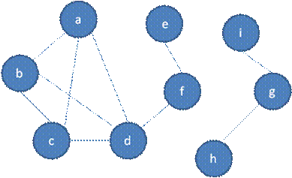  
**Figure 1. Graph 1**

What is the output of breadth-first traversal from vertex b? (visit nodes in ABC order if there are some nodes having the same selection ability).  
2.   Given a graph with adjacency matrix below. Draw the graph and show the output of breadth-first traversal from vertex A? (visit nodes in alphabetical order if there are some nodes having the same selection ability).

|  |  |  |  |  |  |  |  |
| --- | --- | --- | --- | --- | --- | --- | --- |
|  | A | B | C | D | E | F | G |
| A | 0 | 1 | 1 | 1 | 0 | 0 | 1 |
| B | 1 | 0 | 1 | 0 | 1 | 0 | 0 |
| C | 1 | 1 | 0 | 0 | 1 | 0 | 0 |
| D | 1 | 0 | 0 | 0 | 0 | 1 | 0 |
| E | 0 | 1 | 1 | 0 | 0 | 1 | 1 |
| F | 0 | 0 | 0 | 1 | 1 | 0 | 0 |
| G | 1 | 0 | 0 | 0 | 1 | 0 | 0 |

3.   Given a graph below. What is the output of depth-first traversal from vertex A? (visit nodes in alphabetical order if there are some nodes having the same selection ability).  
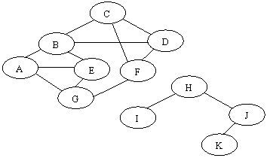

**Figure 2. Graph 2**

4.   Given a weighted graph below and you are using the Dijkstra algorithm to find the shortest path from the vertex 1to the vertex 5. What are the correct order of vertices selected into the set S until the vertex 5 is selected? (Each step a vertex with minimal current distance is selected into S).  
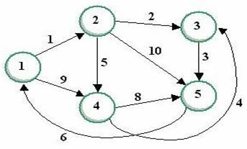  
**Figure 3. Graph 3**

5.   Given a weighted graph above and you are using the Dijkstra algorithm to find the shortest path from the vertex 1 to the vertex 5. What is the label of the vertex 4 when the shortest path from 1 to 5 is determined?

6.   Given a weighted graph below and you are using the Dijkstra algorithm to find the shortest path from the vertex A to the vertex F. What are the correct order of vertices selected into the set S until the vertex F is selected? (Each step a vertex with minimal current distance is selected into S).  
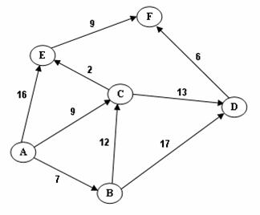  
**Figure 4. Graph 4**

7.   Suppose a multigraph G is given by the adjacency matrix below. Determine whether or not an Euler cycle exists, and if so, provide an example (see the algorithm below).

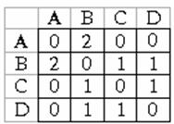  
Suppose the graph G = (V, E) satisfies the conditions for the existence of an Eulerian cycle. The following is an algorithm for finding Euler cycle from the vertex X using stack:

declare a stack S of characters (a vertex is labeled by a character)  
declare an empty array E (which will contain Euler cycle)  
push the vertex X to S  
while S is not empty:  
 ch = top element of the stack S  
if ch is isolated : remove it from the stack and put it to E  
else:  
 select the first vertex Y (by alphabet order), which is adjacent  
   to ch,push  Y  to S and remove the edge (ch,Y) from the graph    
  
the last array E obtained is an Euler cycle of the graph

8.   Suppose a multigraph G is given by the adjacency matrix below. Determine whether or not an Euler path exists, and if so, provide an example.  
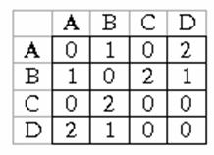  
9.   Suppose a multigraph G is given by the adjacency matrix below. Determine whether or not a Hamilton cycle exists, and if so, provide an example (see the algorithm below).  
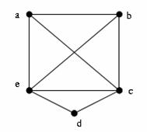  
**Figure 5. Graph 5**

Given the graph G = (V,E) and X is a vertex of  G. Suppose there exists at least one Hamilton Cycle for the graph. The following is a backtracking algorithm for finding one Hamilton cycle from the vertex  X:

declare an empty array H (which will contain Hamilton cycle)  
(1) Put the vertex  X  to  H  
(2) Check if H is a Hamilton cycle then stop, else go to (3)  
(3) Consider the last vertex Y in H, if there is/are vertex(es) adjacent to Y, select the first adjacent vertex Z (by alphabet order) and put it to H. If there no adjacent vertex, remove Y from H and denote it as a bad selection (so you do not select it in the same way again).  
Go to (2).

10. Given a weighted graph below. What is the total edge-weight of the minimum spanning tree of G?

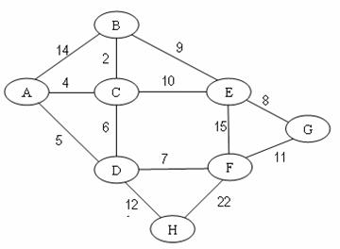

**Figure 6. Graph 6**  
11. Given a graph with weighted adjacency below. What is the total edge-weight of the minimum spanning tree of G?

|  |  |  |  |  |  |  |  |
| --- | --- | --- | --- | --- | --- | --- | --- |
|  | A | B | C | D | E | F | G |
| A | 0 | 14 | 4 | 5 | 0 | 0 | 11 |
| B | 14 | 0 | 2 | 0 | 9 | 0 | 0 |
| C | 4 | 2 | 0 | 6 | 10 | 0 | 0 |
| D | 5 | 0 | 6 | 0 | 0 | 7 | 12 |
| E | 0 | 9 | 10 | 0 | 0 | 15 | 0 |
| F | 0 | 0 | 0 | 7 | 15 | 0 | 8 |
| G | 11 | 0 | 0 | 12 | 0 | 8 | 0 |

12. Given a graph below and colors numbered 1, 2, 3, ... are assigned to vertices with the sequential coloring algorithm that orders vertices by alphabetical order (i.e. the vertex labeled A comes first, then the vertex B,...)  
What is the color of the vertex  H?  
  
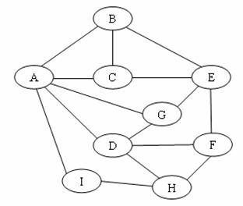  
 **Figure 7. Graph 7**  
13. Given a graph above and colors numbered 1, 2, 3, ... are assigned to vertices with the sequential coloring algorithm that orders vertices in decreasing order of their degrees, (i.e. vertices are put in the largest first sequence)  
What is the color of the vertex H?

**Practical exercises**  
1    Create text files to store the adjacency matrix of a graph in Figure 1. Write the Graph class in Java with the following members :  
Data members:  
 a  -  two dimentional array representing an adjacency matrix  
 label - label of vertices  
 n - number of vertices.  
Methods :  
void setAMatrix(b, m) - set m to n and b matrix to adjancy matrix.  
void setLabel(c) - set labels for vertices  
and two methods for breadth first traverse and depth first traverse.  
2.   Write the WGraph class which contains weighted matrix and methods for Dijkstra shortest path algorithm.  
3.   Write the WGraph class which contains weighted matrix and methods for finding the minimum spanning tree of a graph.  
4.   Write the Graph class which contains adjacency matrix and methods for assigning colors to vertices with the sequential coloring algorithm.